SAP Application Development

(S/4 HANA)

ABAP Objects

Motivation  This chapter explains the main concepts of objects-orientation and their adaption in ABAP. | Prerequisites  You should be familiar with ABAP and the navigation in the SAP system and Eclipse. Furthermore, you should have completed the Introduction to SAP Programming chapter.
Content  This chapter explains how to create simple programs in ABAP Objects. | Lecture notes  The fundamental understanding of the ABAP development in the SAP system is a prerequisite for the students. Students can go on with their account from previous chapters.

- Product: All

- Level: Advanced

- Focus: Programming

- Version: 2.0

- Author: UCC Technical University of Munich

Task 1: Login into the SAP system within Eclipse
Short description: Use Eclipse to login into the SAP system with your username and password
Login

Start Eclipse and select a local workspace where your ABAP project will be stored.

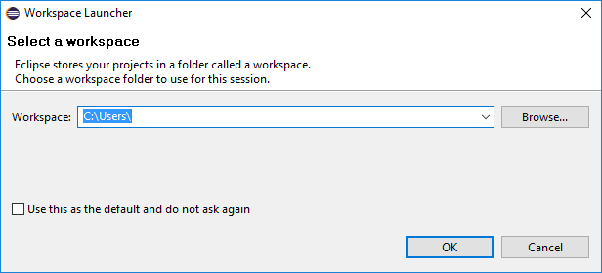

If you have already passed another learning module from this course, navigate to your project and login to the development system using your account from one of the Introduction modules (Introduction to SAP Programming, Development of a first program, ….).
Elsewise create a new ABAP Project and Package according to the instructions in the chapters Introduction to SAP Programming and Development of a first program.

Task 2: Working with ABAP Objects
Short description: Use the concept of ABAP Objects within an ABAP program – create a simple ABAP class.
Create a new ABAP program

To create a new ABAP Program right-click on your package and follow the path

NEW ABAP Program.

Replace ### with your group ID and $$ with your institution ID
Name your ABAP Program ‘Z_$$_###_OBJECTS’.

Please always replace characters ‘###’ with the group ID and $$ with the institution ID assigned to you.

You will create a new local class with the purpose of saving airlines. This class will be called in the program and several new instances of this class will be created.

Create a new include program Z_$$_###_CLASS_INCLUDE. For this, right-click the context menu of Source Library inside your package and select

New ABAP Include.

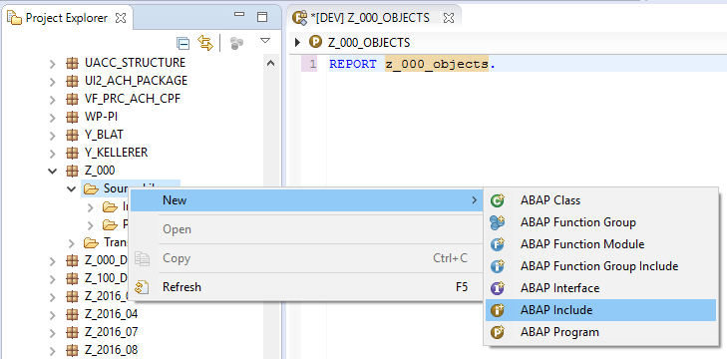

Add command ‘INCLUDE Z_$$_###_CLASS_INCLUDE.’ in your main program ‘Z _$$_###_OBJECTS’. The newly created include program will include definition and implementation of the local class LCL_AIRPLANE.

Declare methods
Please start with the class declaration. You require a method set_attributes and a method get_attributes with public access. Method set_attributes includes an importing parameter im_name for the airplane name and importing parameter im_planetype for the airplane type. Both attributes have to be defined in the private section as attributes. The declaration of the local class is shown in the screenshot below.

Advice: Press Shift + Enter for code completion
Advice: Press Shift + Enter for code completion
Advice: Press Shift+F1 to run the Pretty Printer

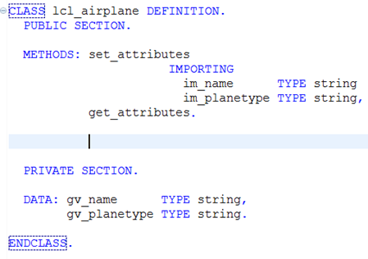
Figure 1 - Z_$$_###_CLASS_INCLUDE

Method set_attributes should provide functionality to set both private attributes name and planetype according to the importing parameters. Method get_attributes should provide functionality to output the attribute values for a certain object with help of the WRITE-command. The implementation of both methods is shown here:
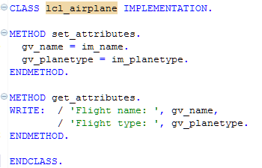
Figure 2 - Z_$$_###_CLASS_INCLUDE
Implementation

The first screenshot illustrates the definition of the class, whereby the second one issues the implementation. Since they are connected to each other, they have to be put into one file.
Please save, check and activate your new program.

Task 3: Implement the use of a class
Short description: Implement the use of the ABAP class created in Task 2.

Please return to the main program in order to implement the use of the class. You will now create several airplanes (objects). The reference on these objects will be stored in an internal table in order to access these objects again at a later date.

The reference r_plane will use a new type definition: It will refer to the local class LCL_AIRPLANE by the use of declaration TYPE REF TO. In the same way the internal table it_plane_list is defined as table of references on this local class.

The data declaration of program ‘Z_$$_###_OBJECTS’ therefore looks as shown in the figure below:

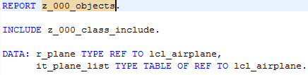
Figure 3 – Z_$$_###_OBJECTS

Now start the block ‘START-OF-SELECTION’ by creating an object with command CREATE OBJECT that is referenced by variable r_plane.
Call method set_attribute using this reference and assign name and planetype to the new object using the corresponding parameters of the method.
Create two objects

Append the reference to table it_plane_list using the command APPEND. By appending the reference, the address of the created object is saved in the table and the reference r_plane itself can be used for other objects. Now create a second new airplane and append this reference to the internal tables as well (compare source code below).
Loop through the list

Finally, you will loop at the internal table and display data for each airplane on the screen using method get_attributes.

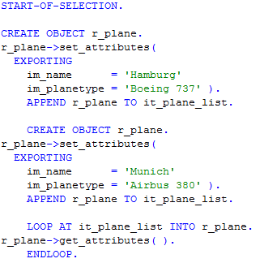
Figure 4 - Z_$$_###_OBJECTS

Please save, check and activate your new program.

Finally test your ABAP Application as shown in the screenshot below:

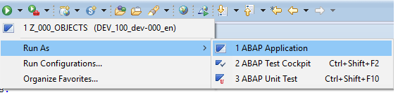

You should see the attributes of both created objects in the SAP GUI.

Task 4: Static components in ABAP Objects
Short description: Implement static components inside your ABAP class.

Until now, only instance attributes and methods have been implemented. Now, we want to count how many airplanes currently exist.

Create a static attribute in the private section of the declaration part of lcl_airplane called gv_no_of_planes. Select data type “Integer”.

Every time an airplane (object) is created, we want to add 1 to the number of airplanes. The method which is called every time an object is created, is the constructor method. So, the coding to raise the number of airplane has to take place in the implementation part of this method. As all methods, the constructor method first needs to be declared in the declaration part of class lcl_airplane.

As the static attribute gv_no_of_planes was declared in the private section of class lcl_airplane, we can not access it directly via the command
lcl_airplane=>gv_no_of_airplanes.

Though we need to implement another method get_no_of_planes exporting the number of airplanes.

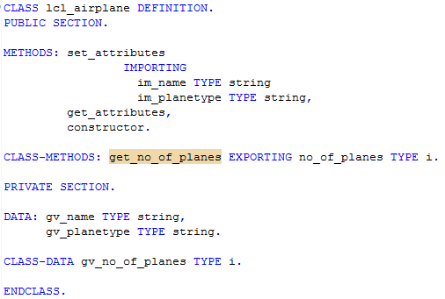
Figure 5 - Z_$$_###_CLASS_INCLUDE

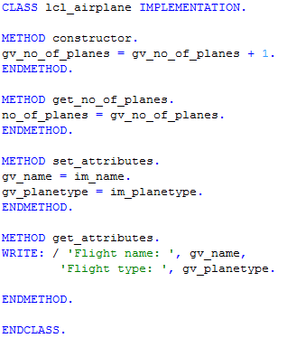
Figure 6 - Z_$$_###_CLASS_INCLUDE

Complete your program ‘Z_$$_###_OBJECTS’ with the commands

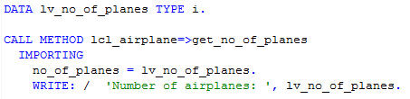
Figure 7 - Z_$$_###_OBJECTS

to display the number of airplanes on the screen.

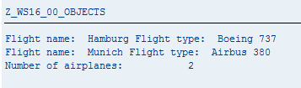

Challenge: Working with ABAP Objects and the Class Builder
Short description: Implement tasks 3 and 4 within the Class Builder

Build class lcl_airplane in the class builder which you can access within the SAP GUI in transaction SE24. To navigate to the SAP GUI, select button ._

As with the Class Builder you can build global classes, please name it

‘ZCL_$$_AIRPLANE_###’ and click on “Create”.
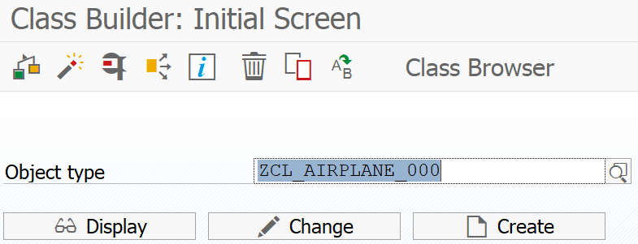

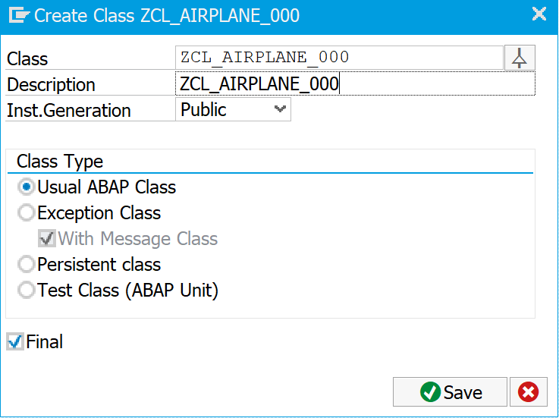
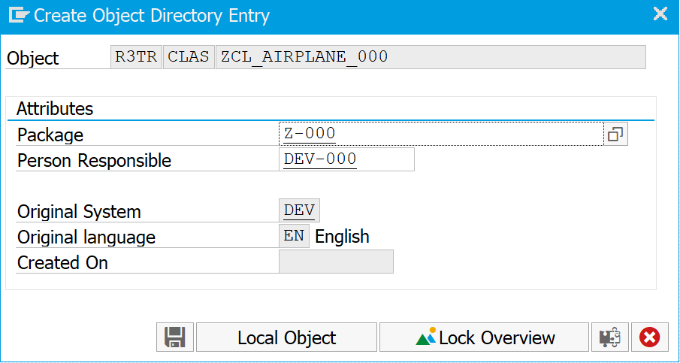

Select Save and then Ok.

The Class Builder supports a very intuitive User Interface, try to implement all attributes and methods as described in tasks 2 and 3!

Create a report ‘Z_$$_###_OBJECTS_GLOBAL’ in analogy to report ‘Z_$$_###_OBJECTS’ with the following exceptions:

As we defined the class as “Public”, it can be accessed from reports. So, you do not any more have to include your class with the help of an include statement into your report.



Furthermore, all occurrences of references to lcl_airplane have to be replaced with a reference to global class zcl_$$_airplane_###.

For experts: Why does the naming of every global class have to be unique (in this case assured by the addition ‘$$’ and ‘_###’ of your institution ID and group ID)?

Save, check, activate your program. You have done very well, if the output screen looks like in task number 4!

